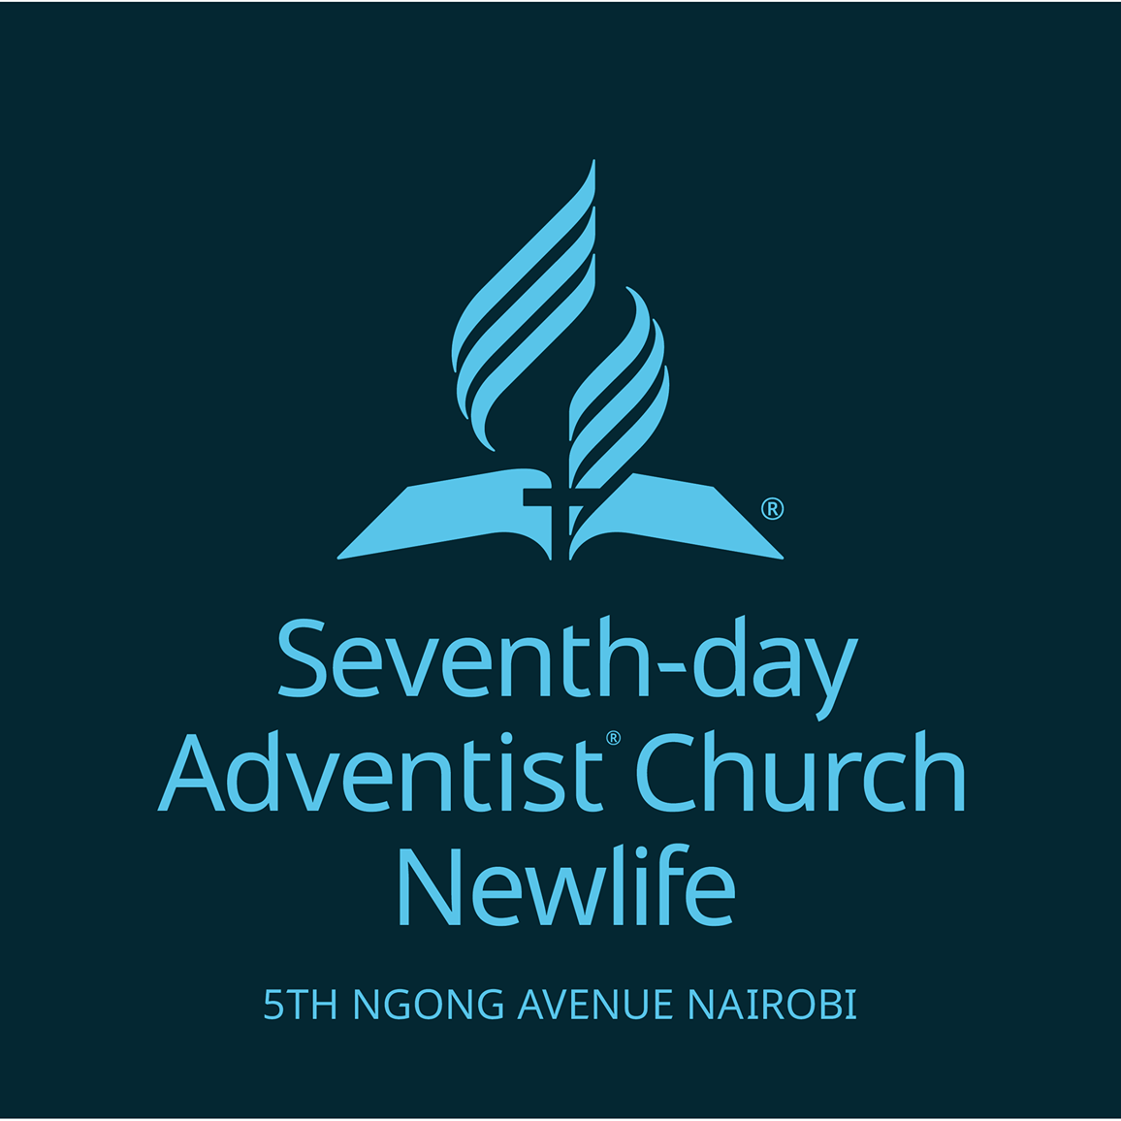

TENDER NO. NWL/PROC/002/2024: OVERHAUL OF PLUMBING FOR NEWLIFE SEVENTHDAY ADVENTIST CHURCH

JUNE 2024

CLOSING DATE: JUNE 8, 2024

CLOSING TIME: 12.00 PM

**INVITATION TO TENDER**

TENDER NO. NWL/PROC/002/2024

Newlife Seventh Day Adventist Church invites bids from interested bidders for overhaul of its plumbing works from established plumbing firms.

Tender document in English detailing the requirement may be obtained from procurement office/treasurer’s office in normal working days between 8 am – 4.30pm upon payment of a **non-refundable fee of Kshs 1,000** Made to Newlife SDA Church

A complete tender document in plain sealed envelopes clearly marked with the tender number and tender description as particularly described in the tender document should be addressed and submitted to:

**CHURCH PASTOR**

**NEWLIFE SEVENTH DAY ADVENTIST CHURCH**

**5 TH NGONG AVENUE**

**P. O. BOX 40829-00100**

**NAIROBI**

And must be deposited in the tender Box at the reception on the Church Administration block on or before 12.00 pm on the closing date against each tender.

* The opening of tender will be done on the same day 12.00pm in the conference room.
* Newlife church reserves the rights to accept or reject any tender and to annul the tendering process and reject all tenders at any time prior to contract award, without incurring liability to the affected tenderer or bidder.
* Therefore any canvassing will render the prospective bidder in-eligible for participation.

**Pastor Jacob Akali**

**Church Pastor**

**TENDER FORM**

|  |  |
| --- | --- |
| **To:**  Bidder Name and Address:  **_________________________________**  P.O. BOX __________________  NAIROBI | **FROM:**  NEWLIFE SDA CHURCH  5 TH NGONG AVENUE  P.O BOX 40829-00100  NAIROBI-KENYA |

1. Having examined the Tender document the receipt of which is hereby duly acknowledged, we the undersigned, offer to provide plumbing overhaul works under this tender in conformity with the said Tender document for the sum of ….……………………………………………………………………………………………………………[Total Tender amount in words and figures].

2. We undertake, if our Tender is accepted, to provide the overhaul of Plumbing works in accordance with the conditions of the tender.

3. We agree to abide by this Tender for a period of 90 days from the date fixed for Tender opening and it shall remain binding upon us and may be accepted at any time before the expiration of that period.

4. This Tender, together with your written acceptance thereof and your notification of award, shall constitute a Contract between us subject to the signing of the contract by both parties.

5. We understand that you are not bound to accept the lowest or any tender you may receive.

**Seller’s Signature**

**FOR OFFICIAL USE ONLY**

**1.__________________________Designation________________Signature_________**

**2.__________________________Designation________________Signature_________**

**3.__________________________Designation_________________Signature_________**

**Date………………...………................ Time…..............................**

**CONDITIONS**

1. The general conditions of contract with the Government of Kenya apply to this transaction. This form properly submitted constitutes the entire agreement.
2. The offer shall remain valid for 30 days from the closing date unless otherwise stipulated by the seller.
3. The buyer shall not be bound to accept the lowest or any other offer in part unless the contrary is stipulated by the seller.

**INSTRUCTIONS**

1. All entries must be typed or written in ink. Mistakes must not be erased but should be crossed out and corrections be made and initialed by the person signing the tender.
2. Quote on each item separately, and in units as specified.
3. This form must be signed by a competent person and preferably it should also be rubber stamped.
4. Each Tender should be submitted separately in a sealed envelope with the tender number endorsed on the outside. Descriptive literature or samples of the items offered may be forwarded with the tender document.

**EVALUATION AND COMPARISON OF TENDERS.**

1. **Mandatory Evaluation**

Tenderers shall be evaluated based on the mandatory requirements indicated below. Bids that are non-responsive to any of the mandatory requirements shall be eliminated from the entire evaluation process and shall not be considered for further evaluation.

|  |  |  |
| --- | --- | --- |
| **S/N** | **DESCRIPTION** | **Responsive**  **(yes or No)** |
| 1 | Certificate of Registration/Incorporation |  |
| 2 | Valid Tax Compliance Certificate |  |
| 3 | Evidence of similar three (3) plumbing works done |  |
| 4 | Tender form duly Completed, Signed and Stamped by the Tenderer in the format provided. |  |
| 5 | Must submit a duly filled Confidential Business Questionnaire Signed and stamped by the tenderer in the format provided. |  |
| 6 | Evidence of Site visit **( Site visit certificate to be attached to response)** |  |

1. **Award of Tender**
2. The bidders with the lowest evaluated bidder who meets all the requirements will be recommended for the award of the contract.

**NEWLIFE SEVENTH DAY ADVENTIST CHURCH**

**CONFIDENTIAL BUSINESS QUESTIONNAIRE**

Tender is instructed to complete the particulars required in this Form and is further reminded that it is an offence to give false information on this Form.

a) **Tenderer's details**

|  |  |  |
| --- | --- | --- |
|  |  |  |
|  |  | NEWLIFE SEVENTH DAY ADVENTIST CHURCH |
|  |  | TENDER NO. NWL/PROC/002/2024 |
|  |  | 8TH JUNE 2024 |
|  |  |  |
|  |  |  |
|  |  |  |
|  |  |  |
|  |  |  |
|  |  |  |
|  |  |  |
|  |  |  |

**General and Speciﬁc Details**

1. **Sole Proprietor,** provide the following details.

Name in full

Age

Nationality

Country of Origin Citizenship

1. **Partnership,** provide the following details.

|  |  |  |  |  |
| --- | --- | --- | --- | --- |
|  |  |  |  |  |
|  |  |  |  |  |
|  |  |  |  |  |
|  |  |  |  |  |

1. **Registered Company,** provide the following details.

i) Private or publicCompany..................................................................................................

i) Private or publicCompany..................................................................

ii) State the nominal and issued capital of theCompany.........................................................

Nominal Kenya Shillings (Equivalent)................................................................................

Nominal Kenya Shillings (Equivalent)....................................................................

Issued Kenya Shillings (Equivalent)....................................................................................

iii) Give details of Directors as follows.

|  |  |  |  |  |
| --- | --- | --- | --- | --- |
|  |  |  |  |  |
|  |
|  |  |  |  |  |
|  |  |  |  |  |
|  |  |  |  |  |

**Schedule of requirements-Technical Specifications**

* **Overhaul of NEWLIFE SDA Church Plumbing System**

**SITE VISIT**

There will be a site visit on 30th May 2024 from 10am -11am .Site visit is a must before quoting for the works. The site visit Certificate **SHOULD** be stamped by the church personnel to confirm the site visit was done and **the certificate will form part of the tender documents**.



**CERTIFICATE OF BIDDER’S VISIT TO SITE**



This is to certify that ……………………………………………………………...………

…………………………………………………….………………………………………

being the authorized representative/Agent of *M/s……………………………………………..*

……………………………………………………………………………….……………

Participated in the site visit of the works for Tender No. **NWL/PROC/002/2024: OVERHAUL OF NEWLIFE SEVENTHDAY ADVENTIST CHURCH PLUMBING SYSTEM**

Signed…………………………………………………………………………….…………

Date…………………………………………………………………………………………

Rubber Stamp ………………………………………………………………………